Austin SCHWINN

Jérémie BLANCHARD

Kernel Methods - Report

Advanced Machine Learning – Practical Session

*GitHub: https://github.com/amschwinn/adv\_machine\_learning\_lab*

UJM Saint-Etienne – Master 2 Machine Learning and Data Mining – 2018/2018

Table of Contents

[Kernel-PCA 3](#_Toc498024743)

[Efficiency 9](#_Toc498024744)

[Kernel K-means 11](#_Toc498024745)

[Efficiency 14](#_Toc498024746)

[Logistic Regression 16](#_Toc498024747)

[Principles 16](#_Toc498024748)

[Comparisons 16](#_Toc498024749)

[One Class SVM and Maximum Enclosing Ball 17](#_Toc498024750)

# Kernel-PCA

We chose to implement PCA and kernel-PCA in Python. We launched multiple PCA tests with different kernels to visualize the differences between them, and see if kernelizing data improved the result.

Kernel PCA, we implemented our own kernels for Gaussian RBF, Linear, Polynomial, and Laplacian Kernel tricks. We also implemented our own function to center the Kernel’s Gram Matrix and a PCA function. There is a separate function to output all the charts used in this report. All the functions we implemented for this section are contained within the PCA.py file in our lab code. We then called our custom function in our lab report and compared them against existing an existing PCA implementation on scikit learn. We did this by generating half-moon, center circle, swiss roll, and classification datasets using scikit learn.

At first, we have done our tests by running the PCA and k-PCA on our data and only keeping the first principal component, let’s see how our data behave with this configuration.

First principal component | Circle shape

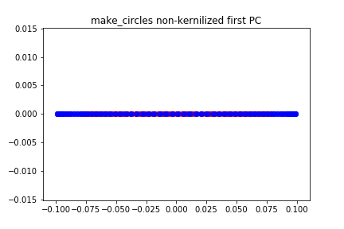

|  |  |
| --- | --- |
|  |  |
| *C:\Users\Jérémie\Desktop\adv_machine_learning_lab\outputs\pca\1st_PC\make_circles poly_kernel first PC.png* | *C:\Users\Jérémie\AppData\Local\Microsoft\Windows\INetCache\Content.Word\make_circles rbf_kernel first PC.PNG* |

By keeping the first principal component, we can see that we are not able to split the data into two different clusters, even with kernels.

Two first principal components | Circle shape

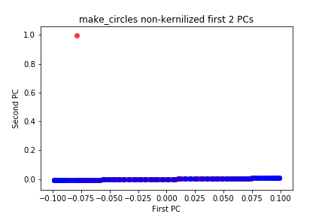

|  |  |
| --- | --- |
|  |  |
|  |  |

Now by using variables in a 2-dimensionals space we can clearly see the effects of kernels. Indeed, without kernel our data are not differentiable except for some outliers. With kernels we have a big improvement and every kernels give a different shape and a different efficiency.

First principal component | Moon shape

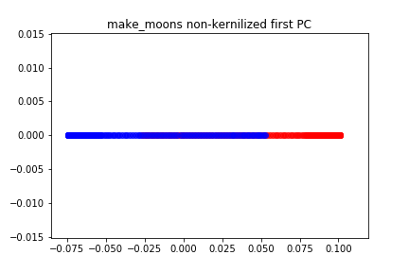

|  |  |
| --- | --- |
|  |  |
|  |  |

Immediately, we see better results with the half-moon shaped data. Unlike the circle shape, the first kernel allows the half moon data to become linearly separable. We achieved the best results with the Gaussian RBF kernel.

Two first principal components | Moon shape

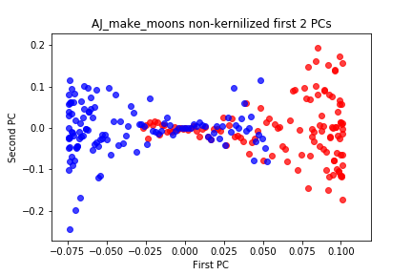

|  |  |
| --- | --- |
|  |  |
|  |  |

We also have better results with our first 2 components using the half-moon shape. Our Gaussian and Laplacian have strong linearly separable results that are easy to differentiate the two classes. Our polynomial kernel can become linearly separable with a small amount of misclassification.

First principal component | Swiss role shape

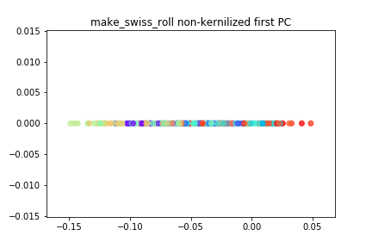

|  |  |
| --- | --- |
|  |  |
|  |  |

The swiss roll dataset gave us the most interesting results. As the y labels of the dataset are continuous and not discrete like the other datasets we used, it is much harder to separate than a 2-class dataset. Our first principle components help separate into a small number of groups but not into results we would like to see.

Two first principal components | Swiss role shape

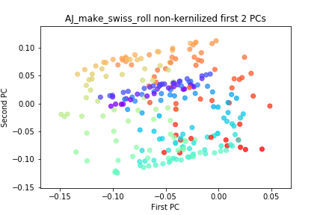

|  |  |
| --- | --- |
|  |  |
|  |  |

This Swiss role shape dataset is a perfect example that some kernels are better than other to classify specific data. The linear kernel is efficient at group close continuous values into discrete groups. This is helpful for other for clustering algorithms. Our RBF and Laplacian kernels separate into 3 distinct groups that are linearly separable but the classes within each group seem too diverse. The polynomial kernel did not achieve very useful results.

### Efficiency

The goal of this experiment was also to run some efficiency test to see if the kernels have an impact on the computing time.

|  |  |  |  |  |  |  |  |  |  |  |  |  |  |  |  |  |  |  |  |  |  |  |  |  |  |  |  |  |  |  |  |  |  |  |  |  |  |  |
| --- | --- | --- | --- | --- | --- | --- | --- | --- | --- | --- | --- | --- | --- | --- | --- | --- | --- | --- | --- | --- | --- | --- | --- | --- | --- | --- | --- | --- | --- | --- | --- | --- | --- | --- | --- | --- | --- | --- |
| |  |  | | --- | --- | | **Moon Dataset** | | | **Kernel** | **Seconds** | | Linear Kernel | 0,0139 | | RBF Kernel | 0,0113 | | Polynomial Kernel | 0,0144 | | Laplacian Kernel | 0,0251 | | |  |  | | --- | --- | | **Circles Dataset** | | | **Kernel** | **Seconds** | | Linear Kernel | 0,0069 | | RBF Kernel | 0,0285 | | Polynomial Kernel | 0,0139 | | Laplacian Kernel | 0,0217 | | |  |  | | --- | --- | | **Swiss Roll Dataset** | | | **Kernel** | **Seconds** | | Linear Kernel | 0,007 | | RBF Kernel | 0,0354 | | Polynomial Kernel | 0,0171 | | Laplacian Kernel | 0,0289 | |

*Computation times comparisons*

|  |  |  |  |  |  |  |  |  |  |  |  |  |  |  |  |  |  |  |  |  |  |  |  |  |  |  |  |  |  |  |  |  |  |  |  |  |  |  |  |  |  |  |  |  |
| --- | --- | --- | --- | --- | --- | --- | --- | --- | --- | --- | --- | --- | --- | --- | --- | --- | --- | --- | --- | --- | --- | --- | --- | --- | --- | --- | --- | --- | --- | --- | --- | --- | --- | --- | --- | --- | --- | --- | --- | --- | --- | --- | --- | --- |
| |  |  | | --- | --- | | **Moon Dataset** | | | **Kernel** | **Variance %** | | Linear Kernel | 100 | | RBF Kernel | 15,0339873 | | Polynomial Kernel | 98,66663 | | Laplacian Kernel | 3,74245794 | | No kernel | 100 | | |  |  | | --- | --- | | **Circles Dataset** | | | **Kernel** | **Variance %** | | Linear Kernel | 100 | | RBF Kernel | 13,3932152 | | Polynomial Kernel | 45,6286997 | | Laplacian Kernel | 2,42600815 | | No kernel | 100 | | |  |  | | --- | --- | | **Circles Dataset** | | | **Kernel** | **Variance %** | | Linear Kernel | 71,8553113 | | RBF Kernel | 1,56018969 | | Polynomial Kernel | 57,6575035 | | Laplacian Kernel | 1,03815176 | | No kernel | 100 | |

*Explained Variance*

Thanks to these data we can deduce that it is possible to find a kernel that runs efficiently, explains the variance of the original dataset when used in PCA, and can help make non-linearly separable data seperable. Through this experiment, we have found that some kernels are better suited for certain tasks over others to on a given dataset. It is possible to choose between a high computational speed, a good classification or a mix of both.

In our example here are the best combinations:

* Moon shape dataset: Linear Kernel – Fast and separate well our data
* Circles shape dataset: Polynomial Kernel – Fast and have a larger margin than the linear kernel
* Swiss Roll dataset: Linear Kernel – Fast and the only one to classify our data without losing too much.

# 

# Kernel K-means

In this section, we used a similar approach to our PCA experiment on the K-Means algorithm. We used our same kernel trick implementations from part 1, which is available in the kernels.py file. We then implemented our own K-Means algorithm which can be found in the kmeans.py file. We iterated over our kernel hyperparameters like gamma for RBF and Laplacian and p for polynomial kernels to find what would give us our best accuracy of classification using the K-Means approach on our 2 class datasets. We compared our K-Means run-time and accuracy compared to scikit learns. Normally, as K-Means is an unsupervised approach, we would not judge our results on accuracy. However, in this use case as we knew our classes, we were able to judge the accuracy at the end of the model to find out best results.

Circles shape dataset

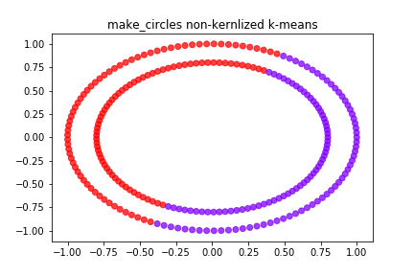

|  |  |
| --- | --- |
|  |  |
|  |  |

The Kernelized K-Means did not perform noticeably better on the circle shaped dataset than the non-kernelized form. For this dataset, SVM would be a better approach for classification.

Moon shape dataset

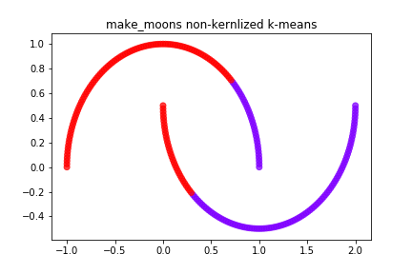

|  |  |
| --- | --- |
|  |  |
|  |  |

With the half-moon dataset, we achieved one good result. We found that the Gaussian RBF kernel is the best kernel trick for this use case. By kernelizing K-Means with the RBF kernel, we were able to achieve 100% accuracy, which is visualized above. Other Kernels performed incrementally better than the non-kernelized form but not enough to justify using them.

Classification dataset

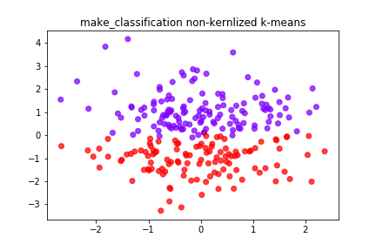

|  |  |
| --- | --- |
|  |  |
|  |  |

## Efficiency

To determine the impact of kernels we saved the accuracy for every K-Means.

|  |  |  |  |  |  |  |  |  |  |  |  |  |  |  |  |  |  |  |  |  |  |  |  |  |  |  |  |  |  |  |  |  |  |  |  |  |  |  |  |  |  |  |  |  |
| --- | --- | --- | --- | --- | --- | --- | --- | --- | --- | --- | --- | --- | --- | --- | --- | --- | --- | --- | --- | --- | --- | --- | --- | --- | --- | --- | --- | --- | --- | --- | --- | --- | --- | --- | --- | --- | --- | --- | --- | --- | --- | --- | --- | --- |
| |  |  | | --- | --- | | **Moon Dataset** | | | **Kernel** | **Accuracy %** | | Linear Kernel | 70,4 | | RBF Kernel | 100 | | Polynomial Kernel | 72,4 | | Laplacian Kernel | 15,2 | | No kernel | 74,4 | | |  |  | | --- | --- | | **Circles Dataset** | | | **Kernel** | **Accuracy %** | | Linear Kernel | 50 | | RBF Kernel | 49,2 | | Polynomial Kernel | 70 | | Laplacian Kernel | 48,8 | | No kernel | 50 | | |  |  | | --- | --- | | **Classification Dataset** | | | **Kernel** | **Accuracy %** | | Linear Kernel | 40,4 | | RBF Kernel | 48,8 | | Polynomial Kernel | 47,2 | | Laplacian Kernel | 36,4 | | No kernel | 37,6 | |

The fact that kernels are behaving in different ways depending of the dataset shape is also verified with K-Means. The Moon dataset is a good example of it because the RBF Kernel allow us to get a 100% accuracy while the Laplacian one only 15,2%.

This also prove that it is important to run several tests with different kernels before choosing one. Because there are big differences in the results, and we should pick carefully a kernel for a specific dataset.

# Logistic Regression

## Principles

Logistic Regression is appropriate for binary response variables where the data can be classified into one or two classes. Other type of Logistic regressions can also classify data in more than two classes by adding “grayscales” between the black and the white classes. But in any case, the response variable is bounded between 0 and 1.

## Comparisons

To compare the regular Logistic Regression with the Kernelized logistic regression we used a dataset called “breast-cancer-wisconsin”. Let’s how our kernels behave with this dataset.

|  |  |
| --- | --- |
| **Kernel used** | **Accuracy %** |
| No Kernel | 0,978914967 |
| Linear | 0,968449404 |
| RBF | 0,630934975 |
| Polynomial | 0,968480185 |
| Laplacian | 0,627425933 |

*Outputs of our Python script*

At first, we see that the kernels are not useful to split these data, because the Logistic Regression with the best result is the one with no kernel. It is also important to see that the kernels that works the best with logistic regression are the Linear one and the Polynomial one, because the Logistic regression is a case of Linear Regression.

# One Class SVM and Maximum Enclosing Ball

We choose to implement the SVDD Problem under the form of an optimization problem on MatLab because we were able to find a toolbox (SVM-KM) which simplify the optimization task. The implemented version of the SVDD problem is the one with slack variables, in this way our maximum enclosing ball is going to make errors.

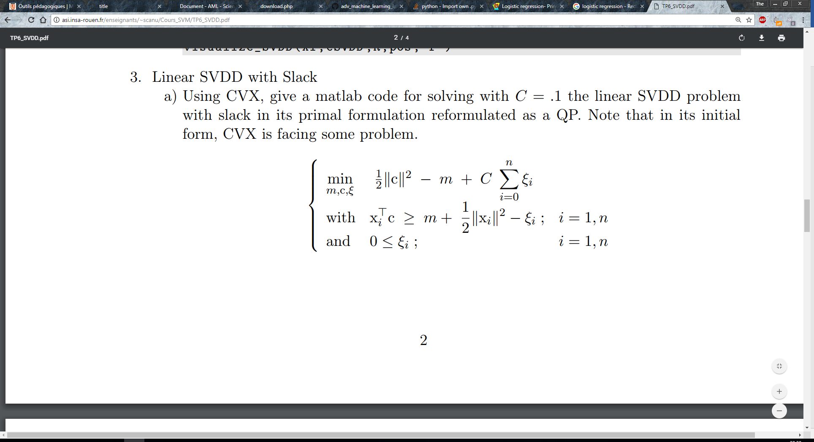

*Optimization problem*

n = 100;

p = 2;

Xi = randn(n,p) + 1.2\*ones(n,1)\*[1 2.8];

G = Xi\*Xi';

nx = diag(G);

e = ones(n,1);

%% SVDD

% min  R^2 + C sum(Xi\_i)   s.t.     \| x\_i - c\|^2  < =  R^2 + xi\_i     pour   i=1,n        et 0 <= xi

% Recasted as a QP

C = 10;

cvx\_begin

cvx\_precision best

variables m(1) cSVDD(2) xi(n)

dual variables d dp

minimize( .5\*cSVDD'\*cSVDD - m + C \* sum(xi) )

subject to

d : Xi\*cSVDD >= m + .5\*nx - xi;

dp: xi >= 0;

cvx\_end

R = cSVDD'\*cSVDD - 2\*m;

pos = find(d > eps^.5);

*Matlab implementation*

To evaluate the performance of this implementation and to compare them with kernels we are going to start with a low C to see if the kernels manage to classify in a better way our data.

C = 0.1

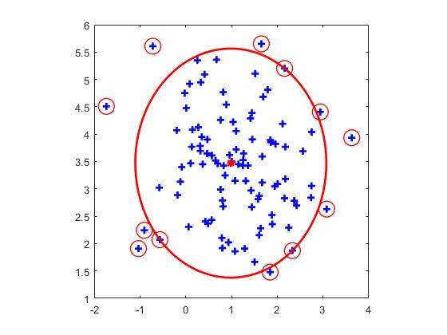

*No kernel*

|  |  |
| --- | --- |
| *Gaussian Kernel* | *Rational Kernel* |

In this case we can see that the gaussian kernel manage better than the rational one to not do any error, but the Rational kernel manage to regroup better the data together than the others.

C = 10

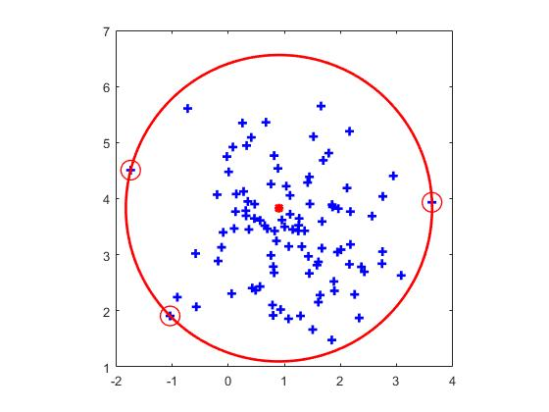

|  |  |
| --- | --- |
| *Gaussian Kernel* | *Rational Kernel* |

Because of a large C the SVDD does not need any kernel to classify every of his example, and the gaussian does not give any improvement, while the rational one is not doing any mistake and regroup all the data together.

As a conclusion we can say that the Rational kernel should be better that the gaussian or no kernel. Indeed, even if it is doing some mistakes it can regroup the data together and at test time it is going to be more accurate.